Laboratoriya ishi – 29
Mavzu : Web socket asosida chat yaratish

Ishning maqsadi:
- WebSocket texnologiyasi bilan tanishish
- Real vaqt (real-time) ishlovchi chat tizimini yaratishni o‘rganish
- PHP yordamida server va mijoz (client) o‘rtasida uzluksiz aloqa o‘rnatish
- Visual Studio Code muhitida amaliy dastur ishlab chiqish

Nazariy qism:

WebSocket nima?
WebSocket — bu client (brauzer) va server o‘rtasida doimiy ochiq aloqa kanali yaratadigan protokol.

HTTP va WebSocket farqi:
HTTP | WebSocket
Har safar yangi so‘rov yuboriladi | Bitta ulanish doimiy ishlaydi
Sekinroq | Tez (real-time)
Bir tomonlama | Ikki tomonlama

Qayerlarda ishlatiladi:
- Chat ilovalar
- Online o‘yinlar
- Birja tizimlari
- Live notificationlar

Loyiha tuzilmasi

websocket_chat/
│
├── server.php
├── composer.json
├── index.html
└── vendor/ (composer o‘zi yaratadi)

Index.php
<?php
// Bu yerda xohlasang server tomonda kichik sozlamalar yozish mumkin
date_default_timezone_set("Asia/Tashkent");
?>

<!DOCTYPE html>
<html>
<head>
<title>PHP WebSocket Chat</title>
<style>
body {
font-family: Arial;
background: #f4f4f4;
padding: 20px;
}
#chat {
background: #fff;
height: 300px;
overflow-y: scroll;
padding: 10px;
border: 1px solid #ccc;
}
input, button {
padding: 10px;
margin-top: 10px;
}
</style>
</head>
<body>

<h2>💬 Chat</h2>

<p>🕒 Server vaqti: <?php echo date("H:i:s"); ?></p>

<input type="text" id="msg" placeholder="Xabar yozing">
<button onclick="sendMessage()">Yuborish</button>

<ul id="chat"></ul>

<script>
var conn = new WebSocket("ws://localhost:8080");

conn.onopen = function() {
console.log("Serverga ulandi");
};

conn.onmessage = function(e) {
var li = document.createElement("li");
li.innerText = e.data;
document.getElementById("chat").appendChild(li);
};

function sendMessage() {
var message = document.getElementById("msg").value;

if(message.trim() === "") return;

conn.send(message);
document.getElementById("msg").value = "";
}
</script>

</body>
</html>

Server.php
<?php
require __DIR__ . '/vendor/autoload.php';

use Ratchet\MessageComponentInterface;
use Ratchet\ConnectionInterface;

class ChatServer implements MessageComponentInterface {
protected $clients;

public function __construct() {
$this->clients = new SplObjectStorage;
echo "✅ Server ishga tushdi (ws://localhost:8080)\n";
}

// Yangi ulanish
public function onOpen(ConnectionInterface $conn) {
$this->clients->attach($conn);
echo "🟢 User ulandi: {$conn->resourceId}\n";
}

// Xabar kelganda
public function onMessage(ConnectionInterface $from, $msg) {
echo "📩 {$from->resourceId} dan: $msg\n";

// HAMMAGA yuboradi (o‘ziga ham)
foreach ($this->clients as $client) {
$client->send("User {$from->resourceId}: $msg");
}
}

// Ulanish yopildi
public function onClose(ConnectionInterface $conn) {
$this->clients->detach($conn);
echo "🔴 User chiqdi: {$conn->resourceId}\n";
}

// Xatolik
public function onError(ConnectionInterface $conn, \Exception $e) {
echo "❌ Xatolik: {$e->getMessage()}\n";
$conn->close();
}
}

// Serverni ishga tushirish
$server = Ratchet\Server\IoServer::factory(
new Ratchet\Http\HttpServer(
new Ratchet\WebSocket\WsServer(
new ChatServer()
)
),
8080
);

$server->run();

Composer.json
{
"require": {
"cboden/ratchet": "^0.4"
}
}

NATIJA
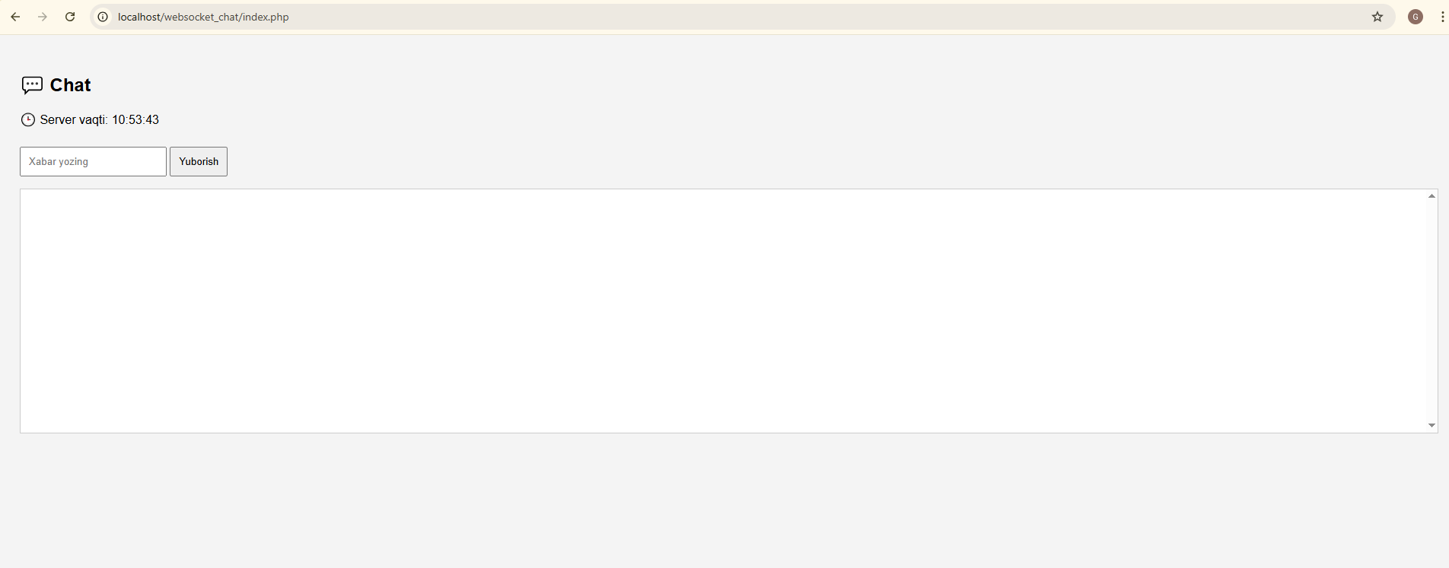
XULOSA
Ushbu laboratoriya ishida WebSocket texnologiyasi o‘rganildi va PHP yordamida real vaqtli chat dasturi yaratildi. Natijada, oddiy HTTP so‘rovlariga qaraganda tezroq va samaraliroq aloqa tizimi hosil qilindi. WebSocket real-time ilovalar yaratishda juda muhim texnologiya ekanligi amalda ko‘rsatildi.

